**CI/CD Automation**

**List of Software’s : -**

1 Java 8 or above (<https://www.oracle.com/in/java/technologies/javase/javase8u211-later-archive-downloads.html>)

2 Jenkins :- <https://www.jenkins.io/download/>

3 GIT :- <https://git-scm.com/downloads>

4 Tomcat 8 or above :- <https://tomcat.apache.org/download-80.cgi>

Assuming all above software are installed and I have pushed my source code to github

<https://github.com/sharadrajore/testcicd.git>

**Note :- If you are not comfortable with CI/CD tool like Jenkins then follow the course on Percipio (https://rpg.percipio.com/)**

<https://rpg.percipio.com/channels/4d42512b-3712-41b6-84c4-d112415a42a3?tab=WATCH>

**Step by Step guide**

1 Login to Jenkins (By default Jenkins runs on port 8080)

I have changed default password and logged in to Jenkins

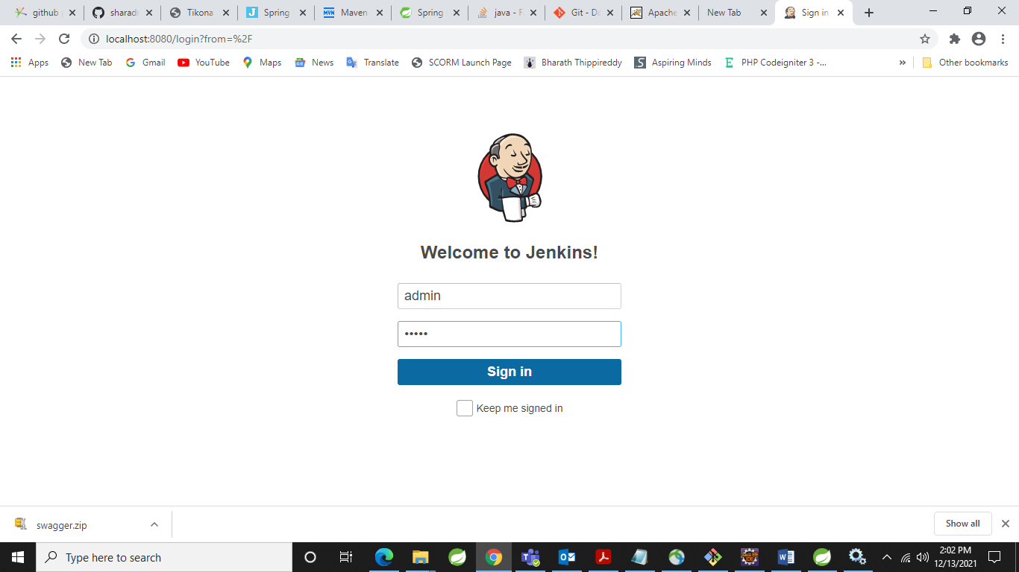

2 Ones you logged in you will see Jenkins Dashboard (You might not have any projects but I have few )

3 Click on New Item (On left side menu)

4 Specify Item Name in my case I have entered war demo Click on Freestyle project and click on ok

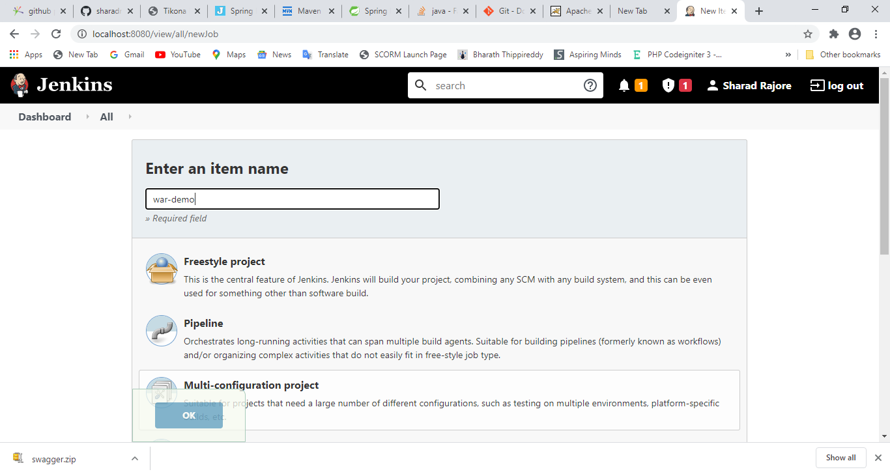

5 Go to Source code Management tab(2nd one)

6 Please select Source Code Management -> Git

7 In Repositories enter repository URL as <https://github.com/sharadrajore/testcicd.git>

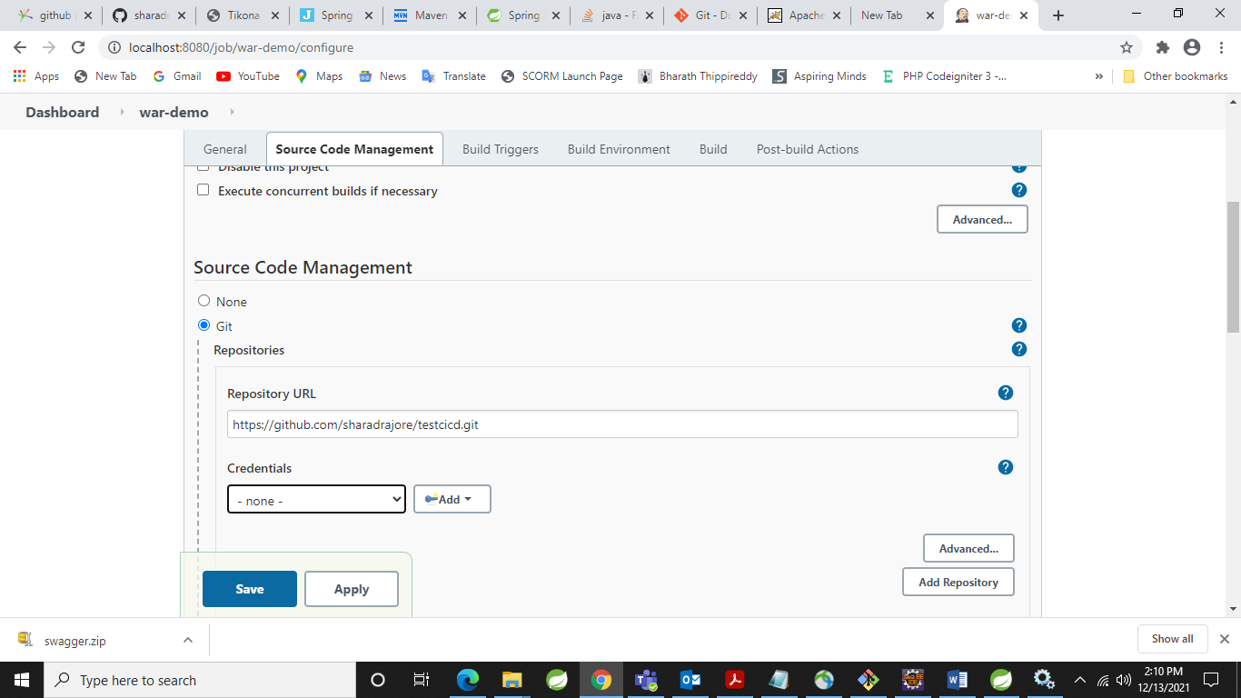

8 As it’s a public repository no need to specify credentials

General Source Code Management Build Triggers Build Environment Build Post-build Actions

9 From above tabs select Build tab and Select Invoke top level Maven target

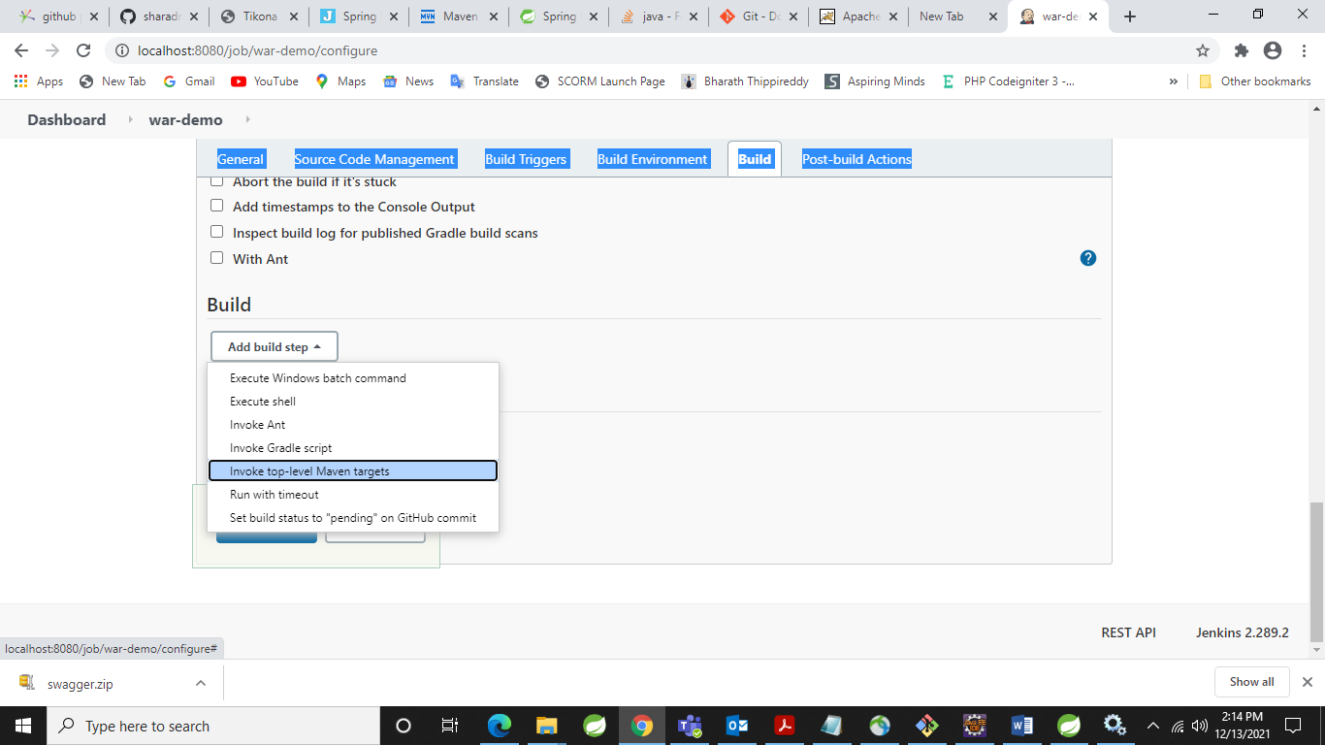

10 Select Maven version you have configured

11 Goals:- clean install (It will create .war file for you.)

12 Now Go to Post –build Actions and select Deploy war/ear to a container

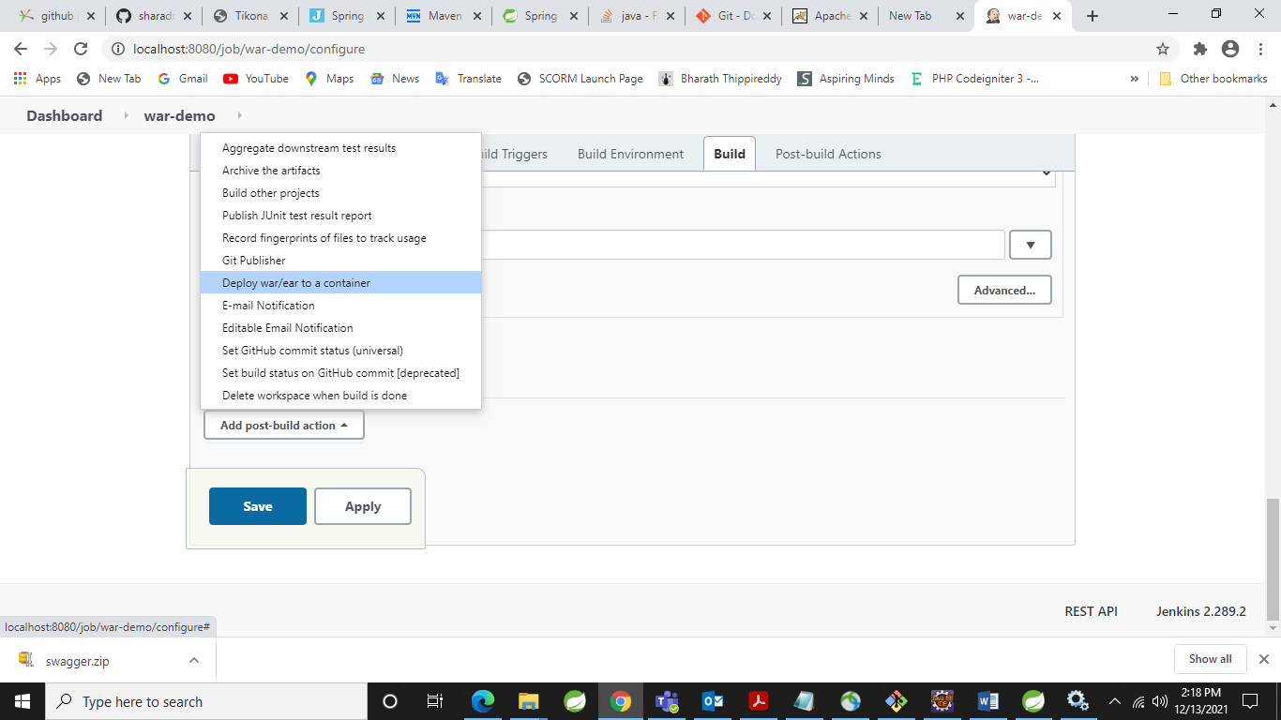

13 In WAR/EAR files type :- **/*.war

14 Keep content-path blank

15 Click on Add Container and select Tomcat 8.x Remote

16 Go to credentials and click on add to create credentials without which you cannot deploy war file which got created in build section .

17 enter tomcat URL on my machine its running on 9090 (make sure your tomcat is up and running)

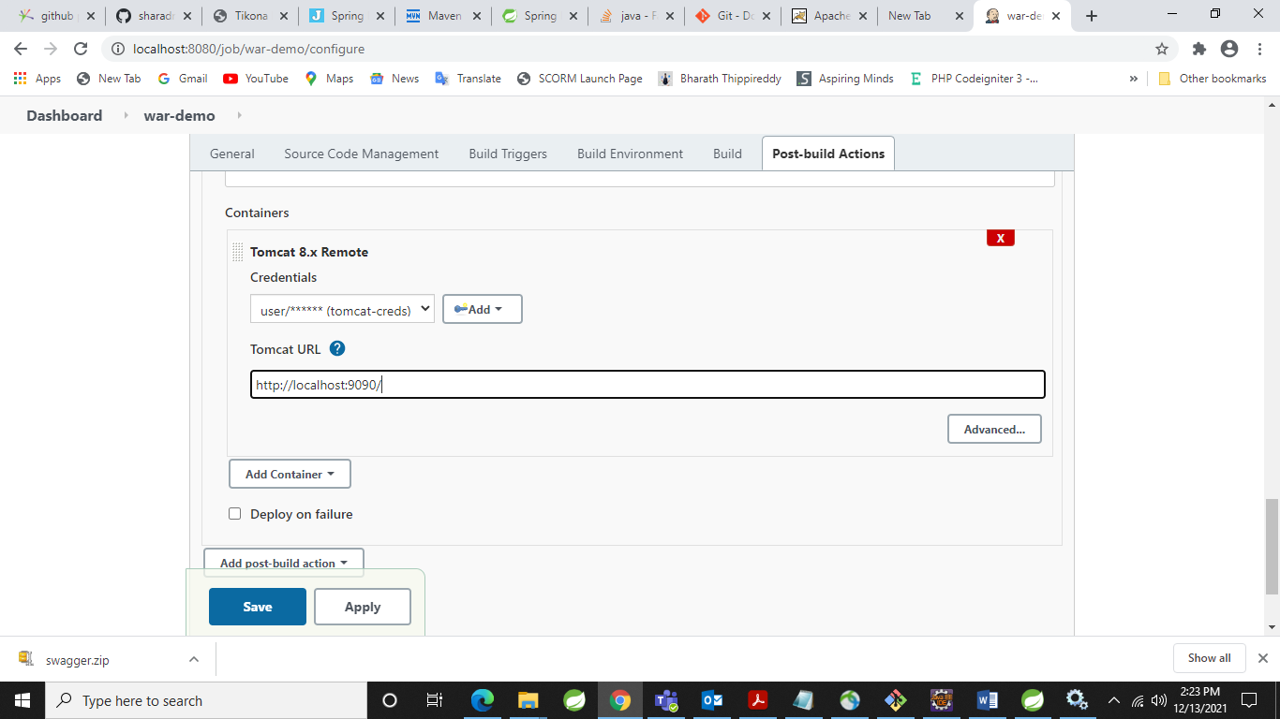

18 Click on Apply and Save

19 Ones you clicked on Save you will get following screen

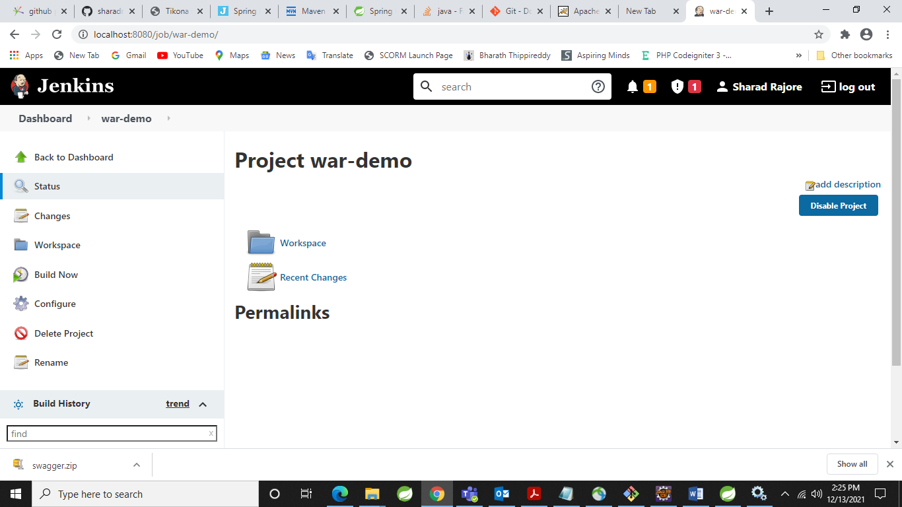

20 Click on Build Now

21 In Build History you can see war has been created and deployed on Tomcat 8.5

22 To see to the log -> go to Build History -> click on Console Output

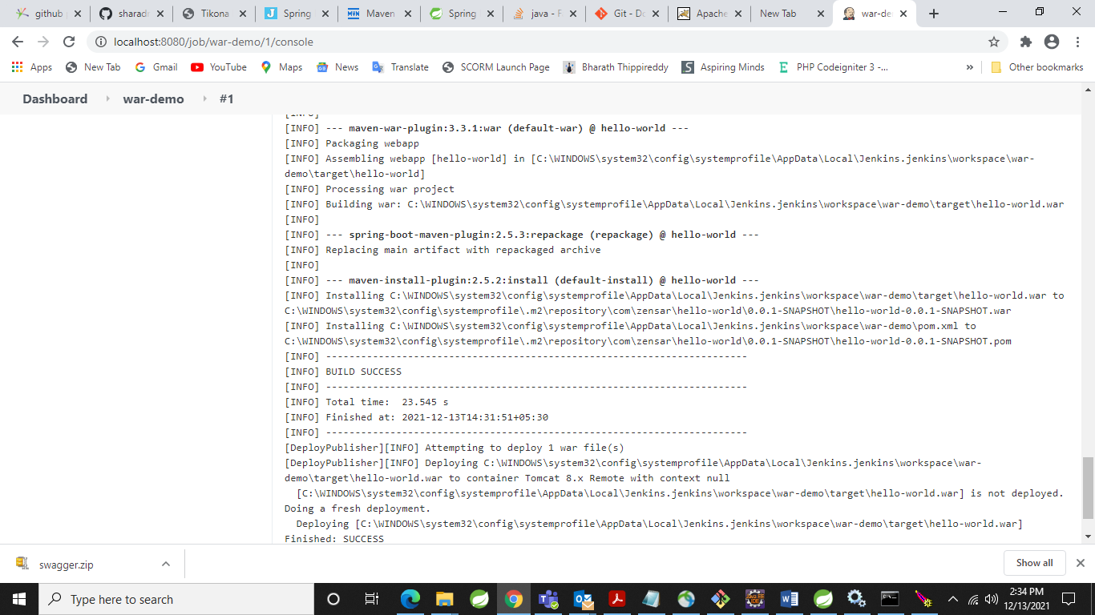

23 Output

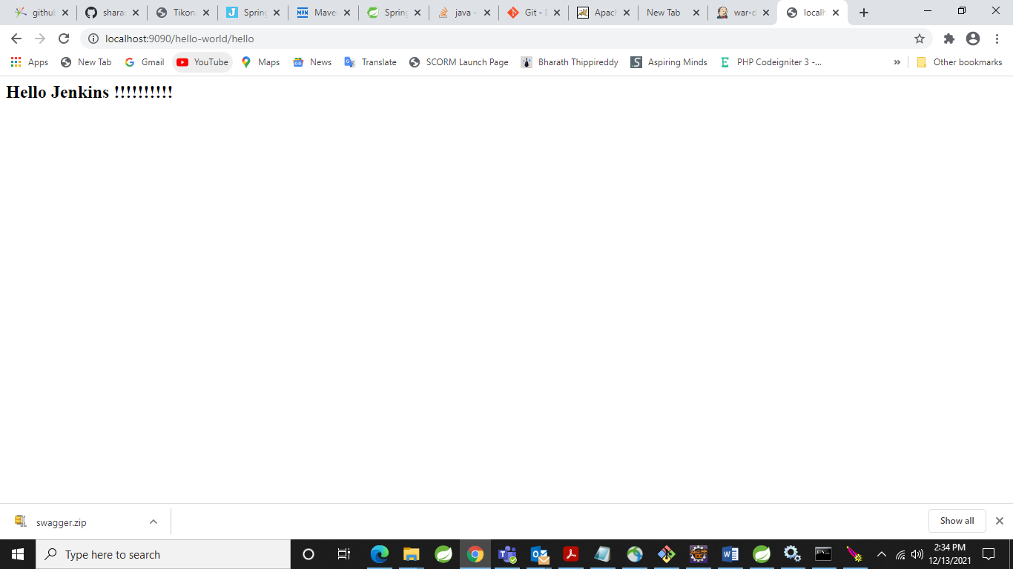

24 For Continuous Integration we want tool like ngrok

Please download it by using <https://ngrok.com/download> link Zip file is getting downloaded

Extract it

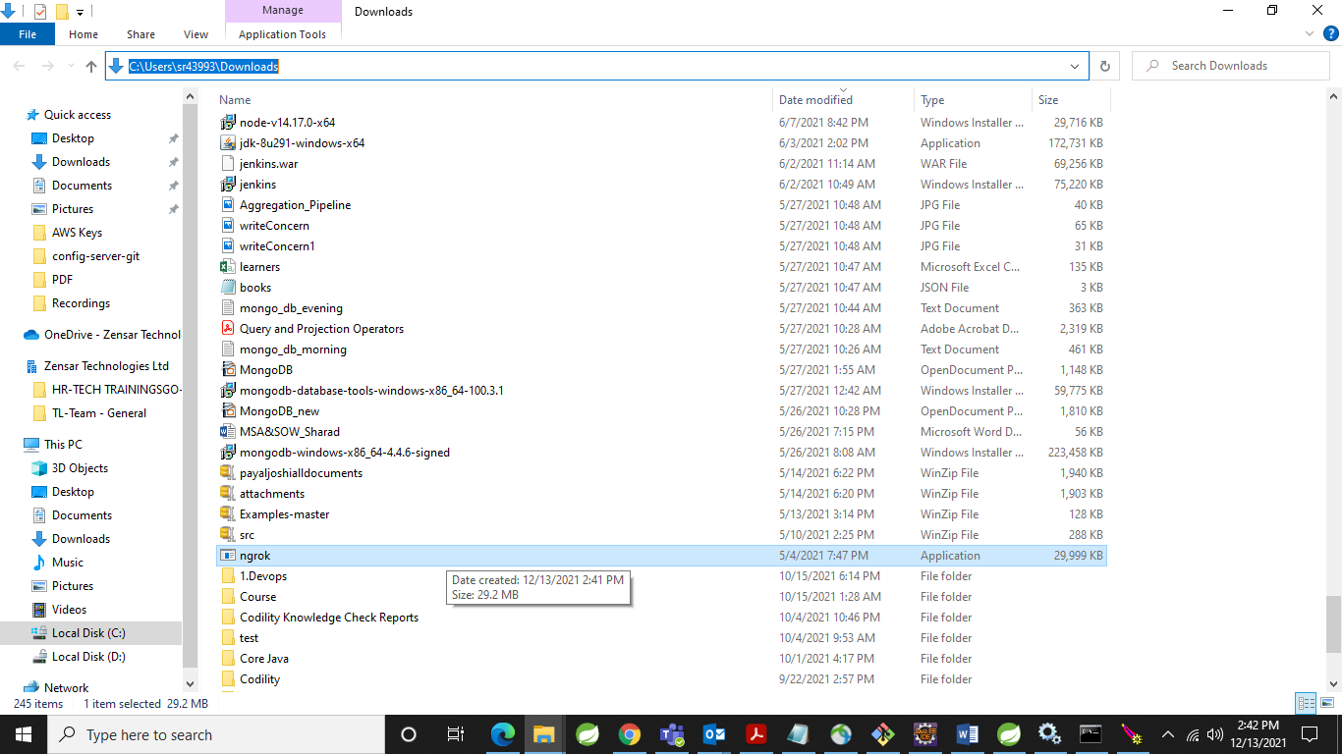

25 Click on ngrok.exe and then type ngrok http 8080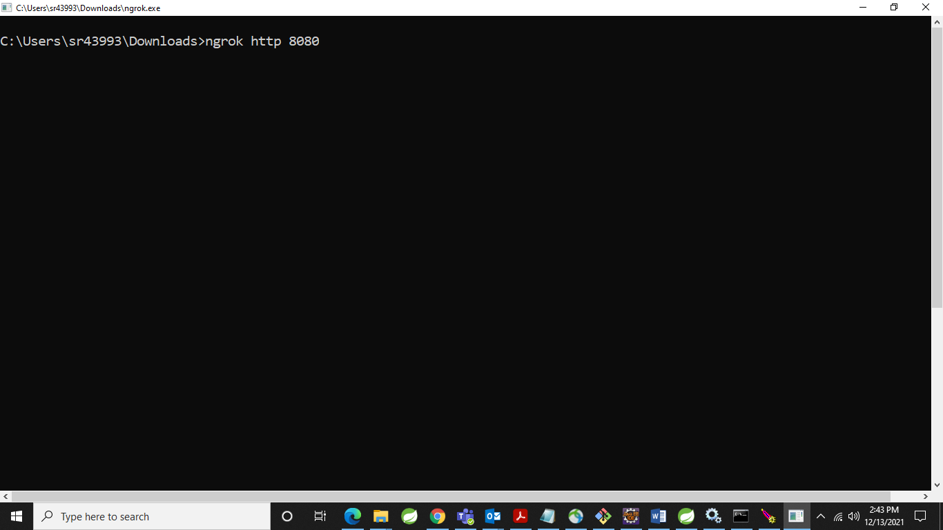

26 Copy the below address (we want that in git repository)

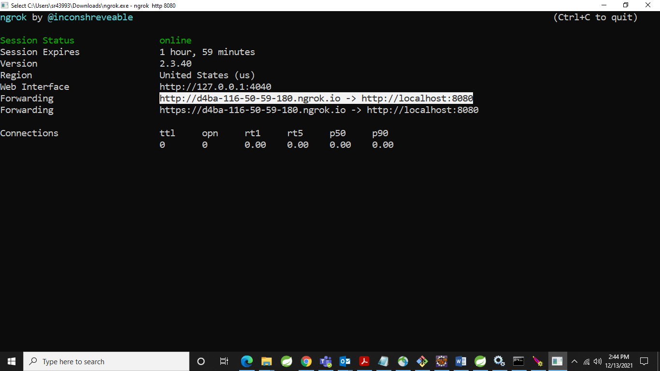

27 Now in Git repository create a web hook for that login to github and go to your repository -> Settings -> Webhooks

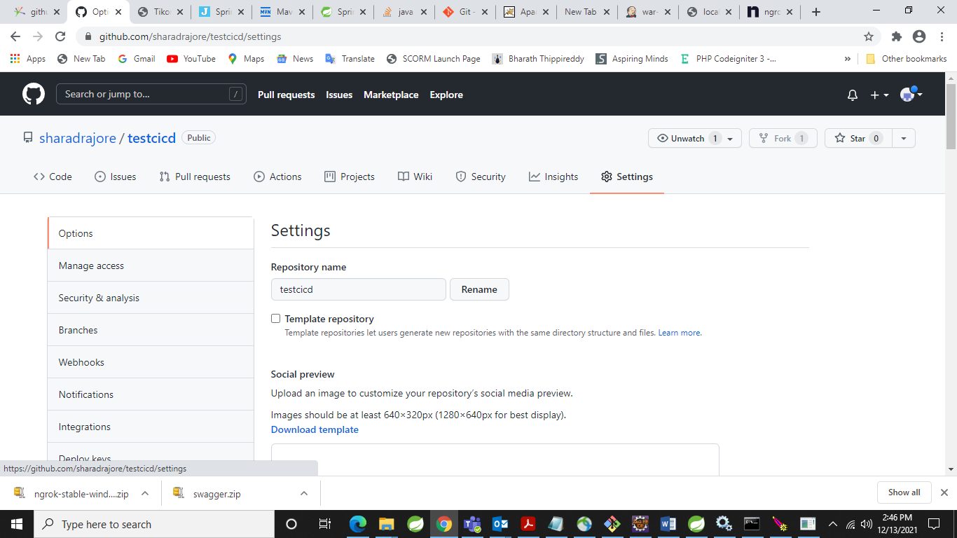

28 Paste the URL generated by ngrok

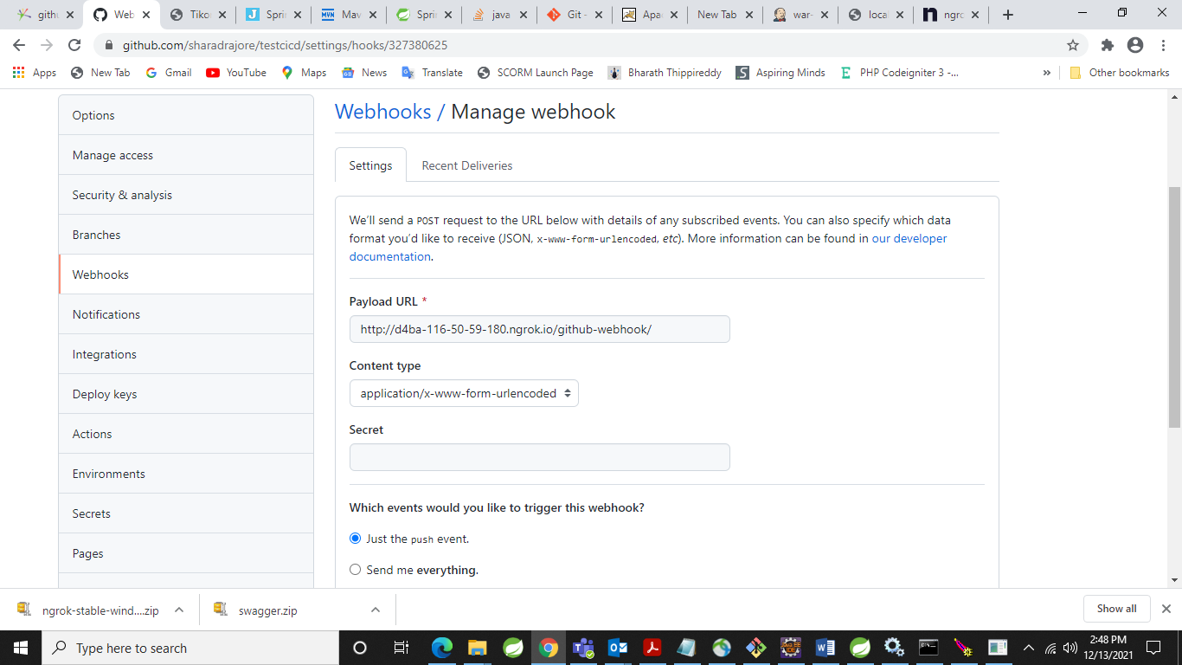

29 Click on Create

30 Now go to code make some changes and commit the changes in local GIT repository or make changes on remote git repository (which is not recommended)

31 To see the effect on continuous integration again go to Jenkins

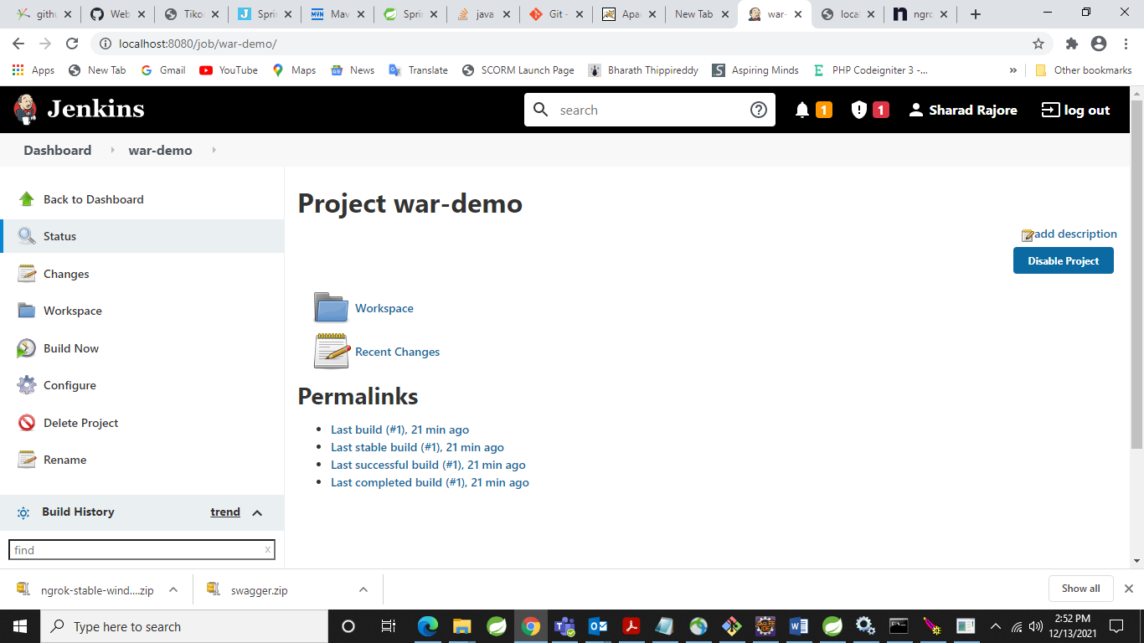

32Click on Configure -> Build triggers -> GitHub hook trigger for GITScm polling

33 Click on Save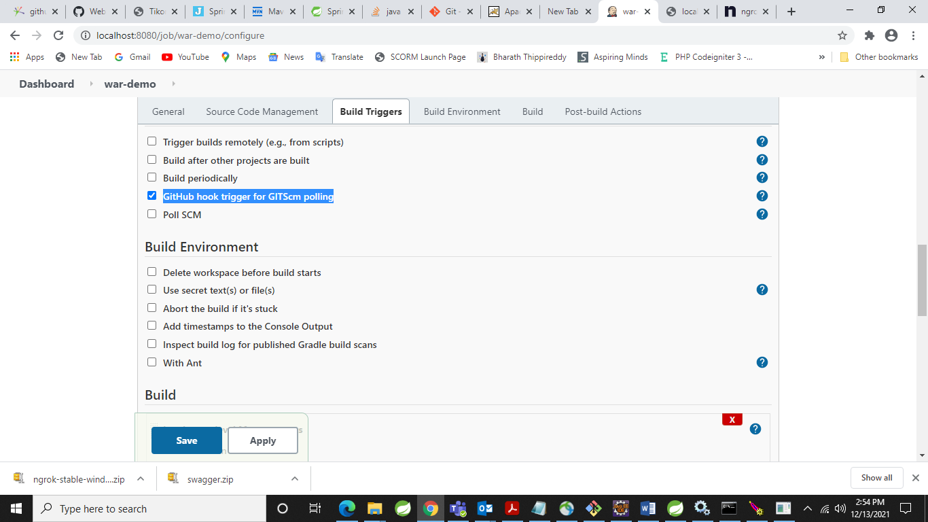

34 I have made changes in code (Removed !!!! signs) now committing to local repository

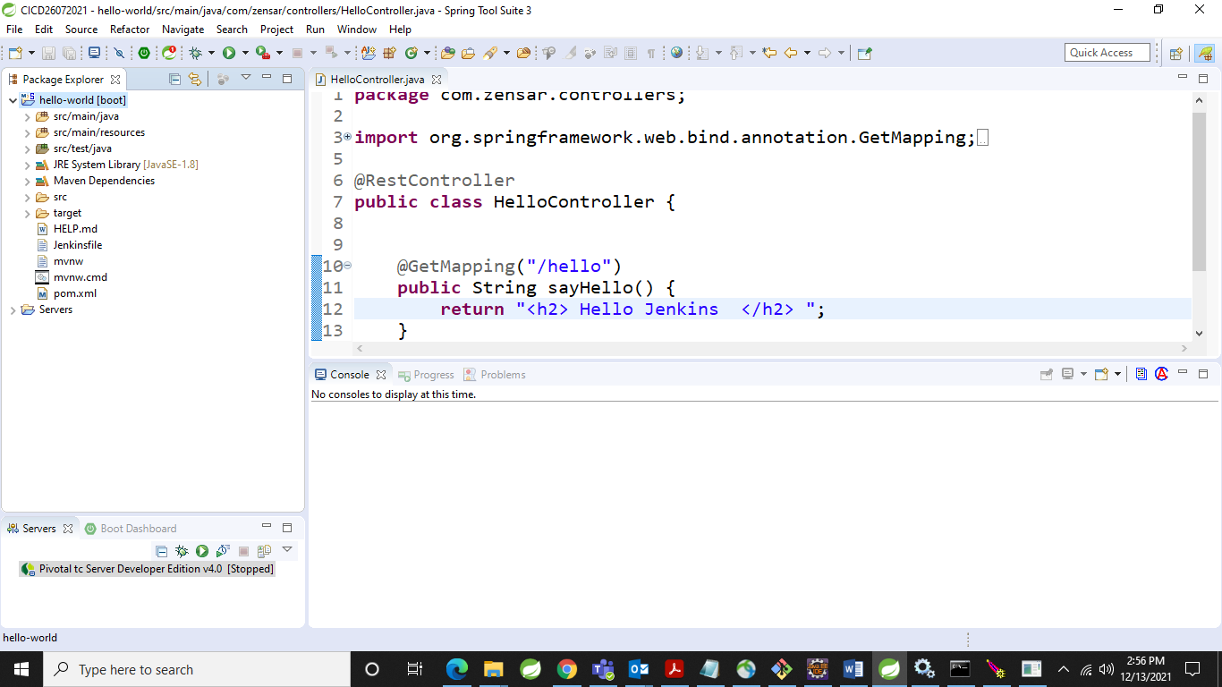

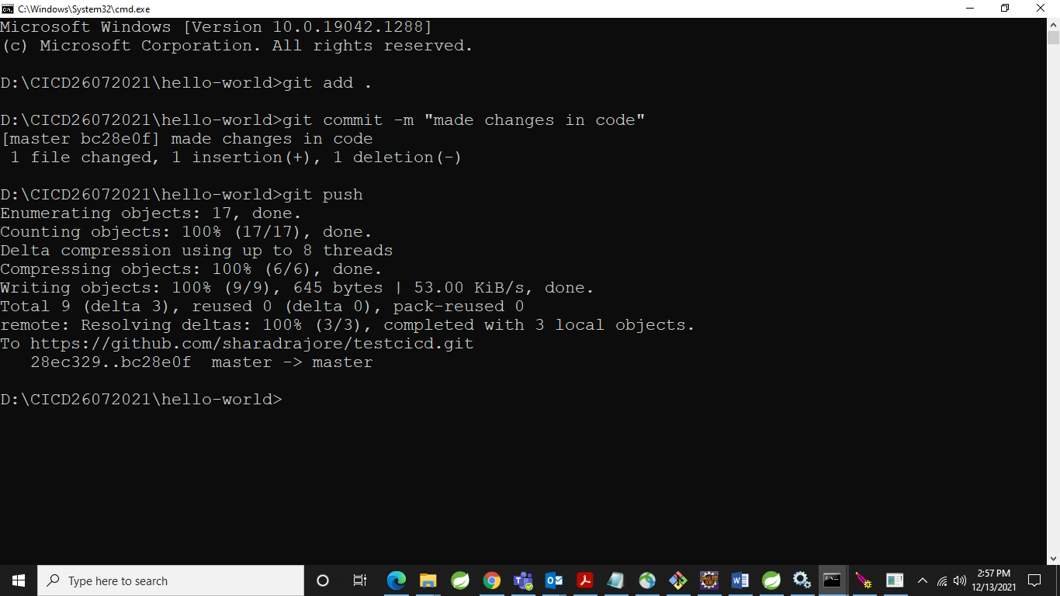

35 Now you can see Second build automatically triggered and you can see the changes in output.